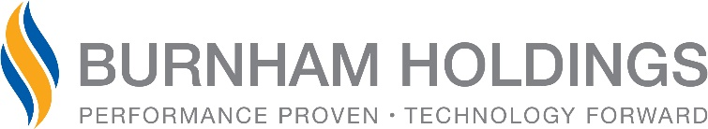

News Release

FOR IMMEDIATE RELEASE

CONTACT: Julia Langsett
Executive Administrative Assistant
Burnham Holdings, Inc.
Work: 717-390-7855
JLangsett@burnhamholdings.com

Christopher Drew named President and COO of Burnham Holdings, Inc.

Lancaster, PA (February 21, 2019) – Christopher Drew was recently promoted to president and chief operations officer for Burnham Holdings, Inc. He assumes the role from Douglas Brossman who, after seven years as president and CEO, will retain his role as chief executive officer. Drew will begin his new role on April 29 at Burnham Holdings’ annual meeting.

Drew, of Lancaster, has served in a variety of positions at Burnham Holdings since 1989, including his most recent position as executive vice president, chief marketing and strategy officer. His notable milestones at Burnham Holdings include founding Thermal Solutions Products in 1996, serving as president of US Boiler from 2007 to 2009 and being elected to the Burnham Holdings board in 2015. He will continue to serve on the board in his new role.

Drew brings extensive knowledge of the HVAC industry to his new position. He has been a long-standing participant in the Air-Conditioning, Heating and Refrigeration Institute (AHRI) and continues to serve on the executive committee of the AHRI board of directors after previously serving as treasurer and chairman.

In his role as chairman of AHRI, he had significant interaction with the federal government on HVAC regulatory issues, which included testifying as an energy policy expert before a congressional committee on the value of the Energy Star program for the HVAC industry in addition to lobbying Department of Energy leadership on efficiency regulations.

“Chris possesses an in-depth knowledge of the HVAC industry and a never-ending desire to meet customer needs,” said Brossman. “Under his leadership, Burnham will continue developing innovative solutions while pursuing strategic market growth.”

Drew is also an active member of the Lancaster business community. He was recently elected as a director for the Economic Development Company of Lancaster and has served on the Lancaster Chamber of Commerce’s Policy Advocacy Committee since 2015.

Drew earned a bachelor’s degree from Dartmouth College and an MBA from New York University.

About Burnham Holdings, Inc.
Burnham Holdings, Inc., (OTC-Pink: BURCA), is the parent company of 14 subsidiaries that are leading domestic manufacturers of boilers and related HVAC products and accessories (including furnaces, radiators and air conditioning systems) for residential, commercial and industrial applications.

Photo Caption
Christopher Drew will be the new president and COO for Burnham Holdings, Inc.
